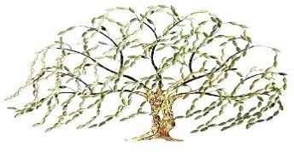
WILLOW TREE ACADEMY
MEMBERS OF SCHOOL IMPROVEMENT BOARDS HERRINGTHORPE JUNIOR SCHOOL

Role | Title | Forename 1 | Forename 2 | Surname | Date of appointment | Date term of office ends/ended
Governor | Mrs | Debra |  | Kelsall | 25 April 2022 | 24 April 2026
Governor
Governor | Mrs | Renee |  | Kirby | 03 Jan 2020 | 2 Jan 2024
Governor | Mrs | Jane |  | Fearnley | 01 Sep 2018
Chair of Governors | Mr | Anthony |  | Trueman | 01 Sep 2022 | 31 Aug 2026
Governor | Mrs | Mandy |  | Adams | 01 Sep 2018
Governor | Mrs | Kate |  | Cooper Johnson | 01 Sep 2022 | 31 Aug 2026
Governor | Rev | Karen |  | Skidmore | 01 Sep 2022 | 31 Aug 2026

