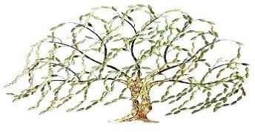
WILLOW TREE ACADEMY
MEMBERS OF SCHOOL IMPROVEMENT BOARDS ROUGHWOOD PRIMARY SCHOOL

Role | Title | Forename 1 | Forename 2 | Surname | Date of appointment | Date term of office ends/ended
Governor | Mr | Nathan |  | Williams | 01 Sep 2018
Governor | Mrs | Lisa |  | Wheeler | 01 Sep 2022 | 31 Aug 2026
Governor | Ms | Frances |  | Hunt | 01 Sep 2022 | 31 Aug 2026
Governor | Mrs | Jane |  | Fearnley | 01 Sep 2018
Governor | Mrs | Jodie |  | Chapman | 08 Jan 2021 | 07 Jan 2025
Governor | Mrs | Nicola |  | Cusworth | 01 Sep 2022 | 31 Aug 2026
Governor
Chair of Governors | Mr | Anthony |  | Trueman | 01 Sep 2022 | 31 Aug 2026

