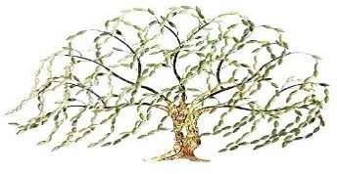
WILLOW TREE ACADEMY
MEMBERS OF SCHOOL IMPROVEMENT BOARDS ROUGHWOOD PRIMARY SCHOOL

Role | Title | Forename 1 | Forename 2 | Surname | Date of appointment | Date term of office ends/ended
Governor | Mr | Nathan |  | Williams | 01 Sep 2018
Governor |  | Lisa |  | Wheeler | 01 Sep 2018 | 31 Aug 2022
Governor |  | Frances |  | Hunt | 01 Sep 2018 | 31 Aug 2022
Governor |  | Jane |  | Fearnley | 01 Sep 2018
Governor |  | Cassie |  | Petch | 01 Sep 2018 | 31 Aug 2022
Governor |  | Nicola |  | Cusworth | 01 Sep 2018 | 31 Aug 2022
Governor | Mr | STEPHEN |  | WHITEHOUSE | 01 Sep 2018 | 31 Aug 2022
Chair of Governors | Mr | Anthony |  | Trueman | 01 Sep 2018 | 31 Aug 2022

