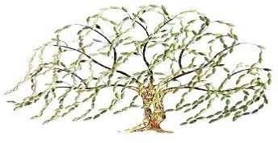
WILLOW TREE ACADEMY
MEMBERS OF SCHOOL IMPROVEMENT BOARDS GREASBROUGH PRIMARY SCHOOL

Role | Title | Forename 1 | Forename 2 | Surname | Date of appointment | Date term of office ends/ended
Governor | Mrs | Kelly |  | Williams | 16 Jan 2020 | 15 Jan 2024
Governor |  | Donna |  | Fisher | 01 Nov 2018 | 31 Oct 2022
Governor | Mr | Anthony |  | Trueman | 01 Sep 2018 | 31 Aug 2022
Chair of Governors |  | Rebecca |  | Barker | 01 Sep 2018 | 31 Aug 2022
Governor | Mrs | Joanne |  | Cook | 01 Sep 2018
Governor |  | Sarah |  | Jenkinson | 01 Sep 2018 | 31 Aug 2022
Governor | Mrs | June |  | Lee | 01 Sep 2018 | 31 Aug 2022
Governor |  | Jane |  | Fearnley | 01 Sep 2018

